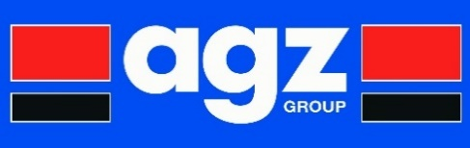

**Competence & Development Policy**

**AGZ Group** is committed to providing our employees with the best possible training and personal development opportunities to help them succeed in their chosen career path within our business.

We support our employees who have the desire for self-development through gaining relevant qualifications. It is our approach to provide further education or skills training to all employees where appropriate and to actively encourage participation in these learning and development activities.

Examplesof development training provided to and completed by AGZ Group employees include:

IOSH Managing Safely, ISO 9001:2015 Internal and Lead Auditor; IEMA Internal Auditor; Honours Degree in Engineering Management; Level 5 NVQ Diploma in Occupational Health and Safety Practice; FLT Operator and Refresher Training; FLT Instructor Training; Tele-Handler Operator; Fire Marshal; First Aider; Edge Cam Training; Visual Welding Inspector; NEBOSH General Certificate; Confined Space; PASMA; IPAF; Doms/Water Hygiene; CSCS Card; Abrasive Wheels; Manual Handling; Electrical Inspection; SSSTS Site Supervisor Training; Level 3 Modern Apprenticeship Programmes.

Over the past 5 years AGZ Group have invested £118k and provided 409 learning days to support employee development opportunities and to ensure our people are provided with the latest up to date knowledge, skills and competence to meet and exceed our customer, business and regulatory requirements. We view this investment in the development of our people as a fundamental element in our long-term business strategy.

**AGZ Group – Investing in Our Future**

**This document was last reviewed January 2018.**

**A signed copy of this statement is available on request.**